# References

* <https://blogs.msdn.microsoft.com/benjaminperkins/2017/04/04/setting-up-and-using-github-in-visual-studio-2017/>
* <https://github.com/garydw/sci-fair-2018>

# Source control

## Setup

We’re using github.com

1. Setup your account.
2. Setup your repository.

## Add collaborators

Adding collaborators lets other contribute to your project.

1. Settings > Collaborators > enter username.

# Development IDE

IDE: Visual Studio 2017.

## Install the Github extension

1. VS > Tools > Extensions and Updates…> click Online > Search: github extension
2. Select Github Extension for visual studio > Download.
3. Exit visual studio > install plugin > startup visual studio.

Now, you should see this in the team explorer:

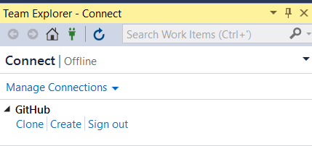

## Clone the repository

This allows you to sync up the new repository that you created and start coding under version control.

1. Visual studio > team explorer > github > click clone
2. Select the repository.
3. Enter a path to store the repository > c:\users\[you]\source\repos

Now you should see something like this:

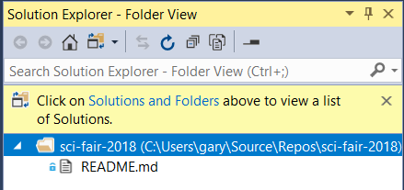

# Python setup for development

## Virtual environments

Setup virtual environment to provide isolation of the python packages needed for this project.

Guide: <http://docs.python-guide.org/en/latest/dev/virtualenvs/>

1. pip install --user pipenv
2. py -m site --user-site

C:\Users\gary\AppData\Roaming\Python\Python36\site-packages

1. Update my system path to:

C:\Users\gary\AppData\Roaming\Python\Python36\Scripts

1. Windows key > system environment > press enter > Environment variables > User variables
2. Click path > click edit > add the above folder at the TOP of the list.

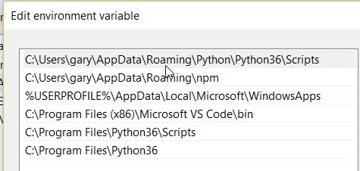

# Setup PdfExtractor

## Dependencies

1. Project bin folder
   1. Create project bin folder to hold all binary dependencies.
      1. C:\Users\[you]\source\repos\sci-fair-2018\bin
   2. Add the project bin folder to your path:
      1. Windows key > system environment > environment variables > user > click new
      2. add C:\Users\[you]\source\repos\sci-fair-2018\bin to the TOP of the list.
2. Openslide binaries
   1. Download openslide.
   2. Copy all files in openslide\bin folder to C:\Users\[you]\source\repos\sci-fair-2018\bin
3. Close any command prompt that might be open and re-open it (to force the new paths to take effect).

## Setup python virtual environment

1. Create the virtual environment following these commands:

C:\Users\gary\source\repos\sci-fair-2018>md env

C:\Users\gary\source\repos\sci-fair-2018>virtualenv env

Using base prefix 'c:\\program files\\python36'

New python executable in C:\Users\gary\source\repos\sci-fair-2018\env\Scripts\python.exe

Installing setuptools, pip, wheel...done.

1. Execute: env\Scripts\activate
   1. This ensures PIP will install any following packages in your virtual environment.
2. Install the following dependencies (**while “activated” from the step above**):
   1. openslide-python
   2. pyodbc
   3. pandas
   4. jupyter

## Setup VS solution

1. VS > file > new project > installed > other languages > python > python application
2. Name > PdfExtractor
3. Location > C:\Users\gary\source\repos\sci-fair-2018
4. Click ok.

You should see:

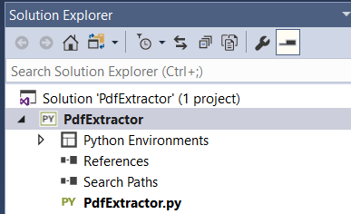

1. Add the virtual environment to the solution:
   1. Solution explorer > Right-click Python environments > add virtual environment
   2. Select C:\Users\[you]\source\repos\sci-fair-2018\env
2. If you expand the Python Environments > env folder you should see all of the installed python packages.

## Setup Jupyter kernel for virtual environment

1. Enter the following commands at the prompt (running under activated):

(env) C:\Users\gary\source\repos\sci-fair-2018>python -m ipykernel install --user --name=sci-fair-2018-env

Installed kernelspec sci-fair-2018-env in C:\Users\gary\AppData\Roaming\jupyter\kernels\sci-fair-2018-env

# Executing Jupyter

C:\Users\gary\source\repos\sci-fair-2018>jupyter notebook

Click New > sci-fair-2018-env

